

EFS & EBS

L. SAI DEEPTHI

[saideepthilanka6950@gmail.com](mailto:saideepthilanka6950@gmail.com)

Batch:122

Date:17/04/2024

1. Create an EFS and attach to two EC2 instance. Create an EBS and attach it to two ec2 instances.

EBS

Step 1: Create an EC2 instance and name it as ‘vmr’ in ubuntu and attach with key pair and launch an instance.

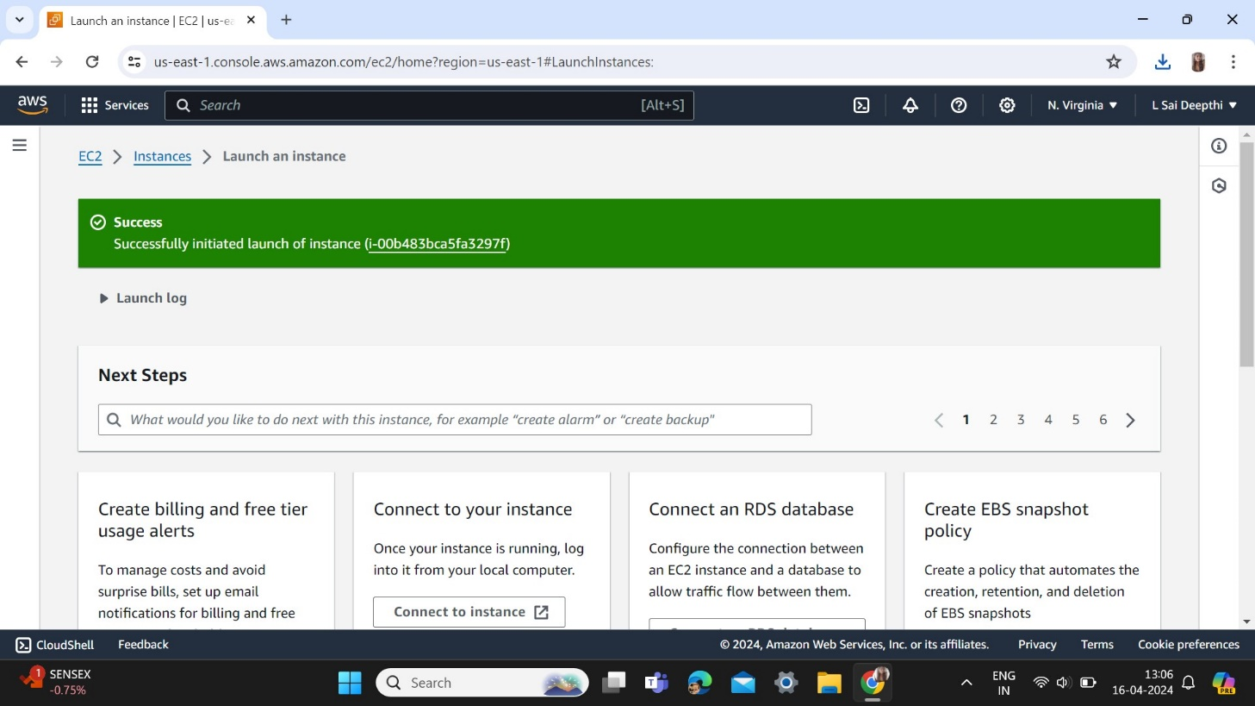

Step 2: Connect to the instance and we can see that the default storage is 8GB

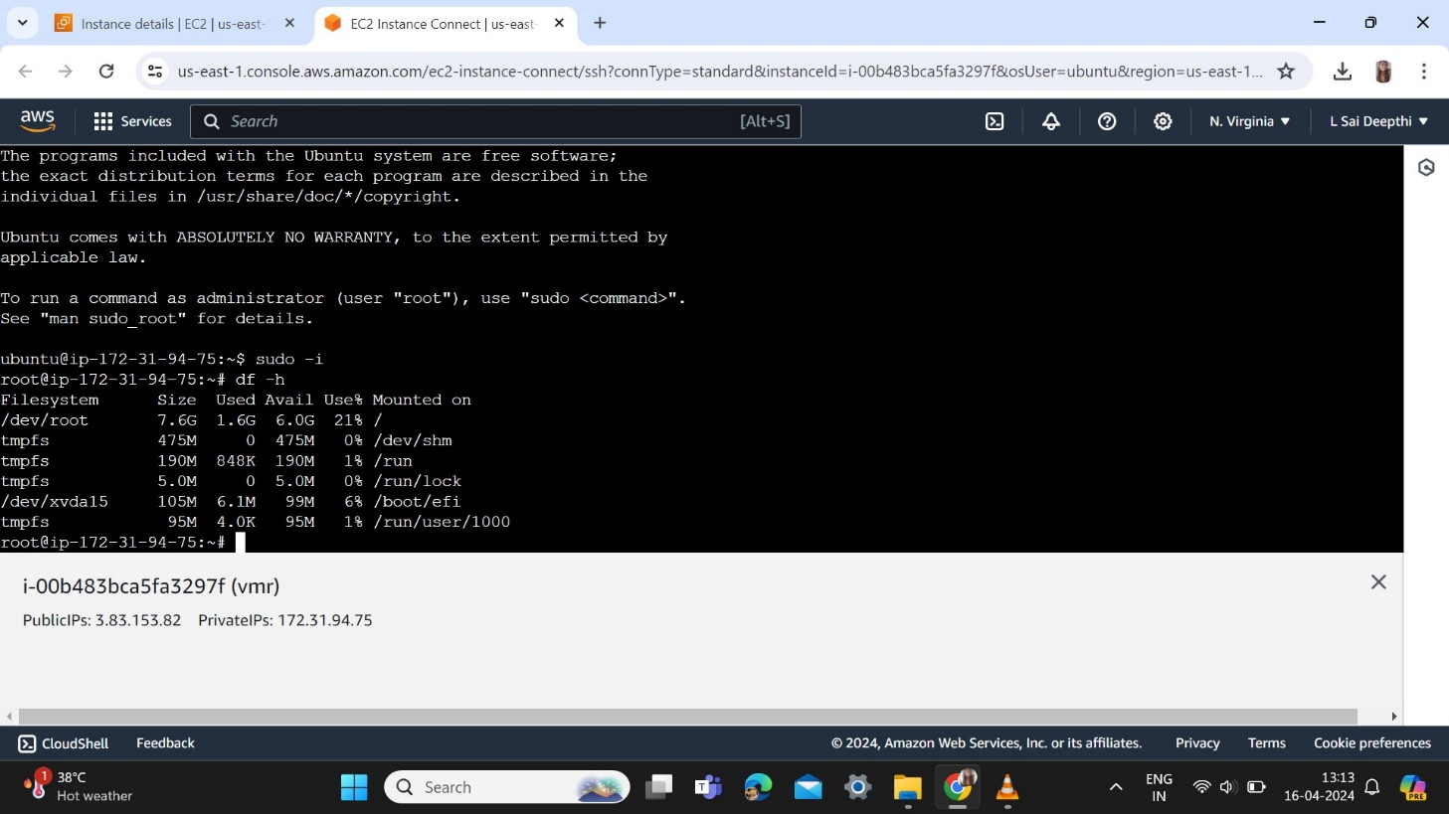

Step 3: Edit the size of the volume and update it, size will be of “16GB”

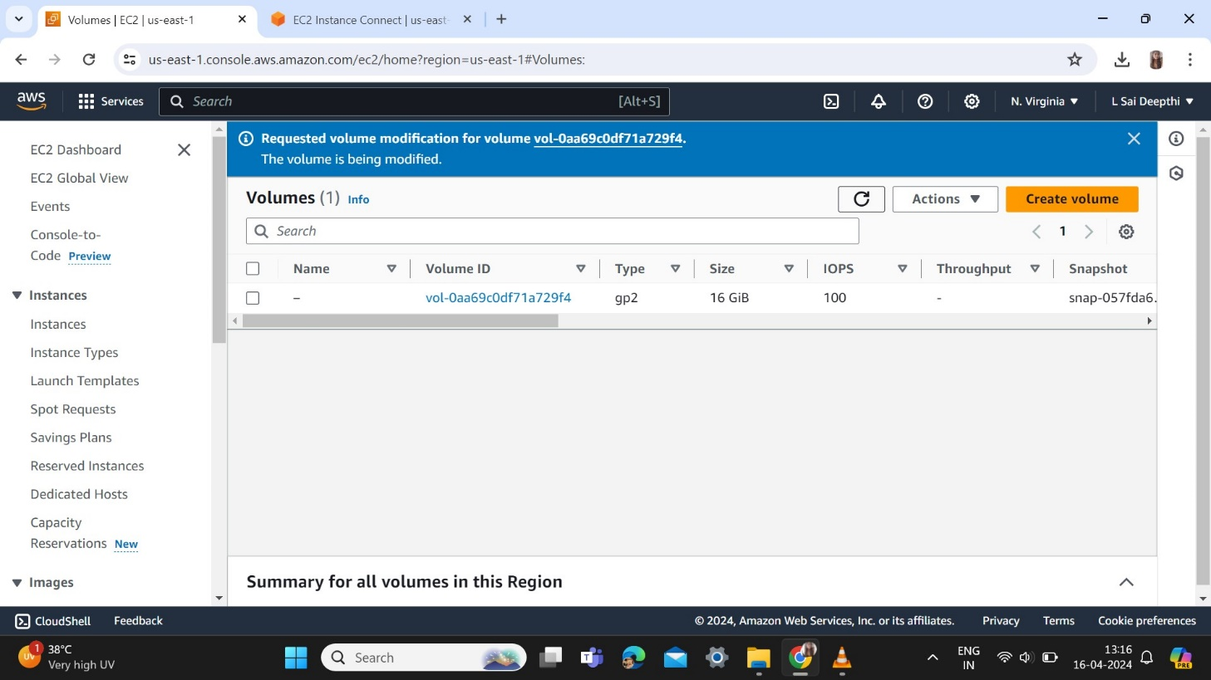

Step 4: Go to instance and Reboot the instance vmr

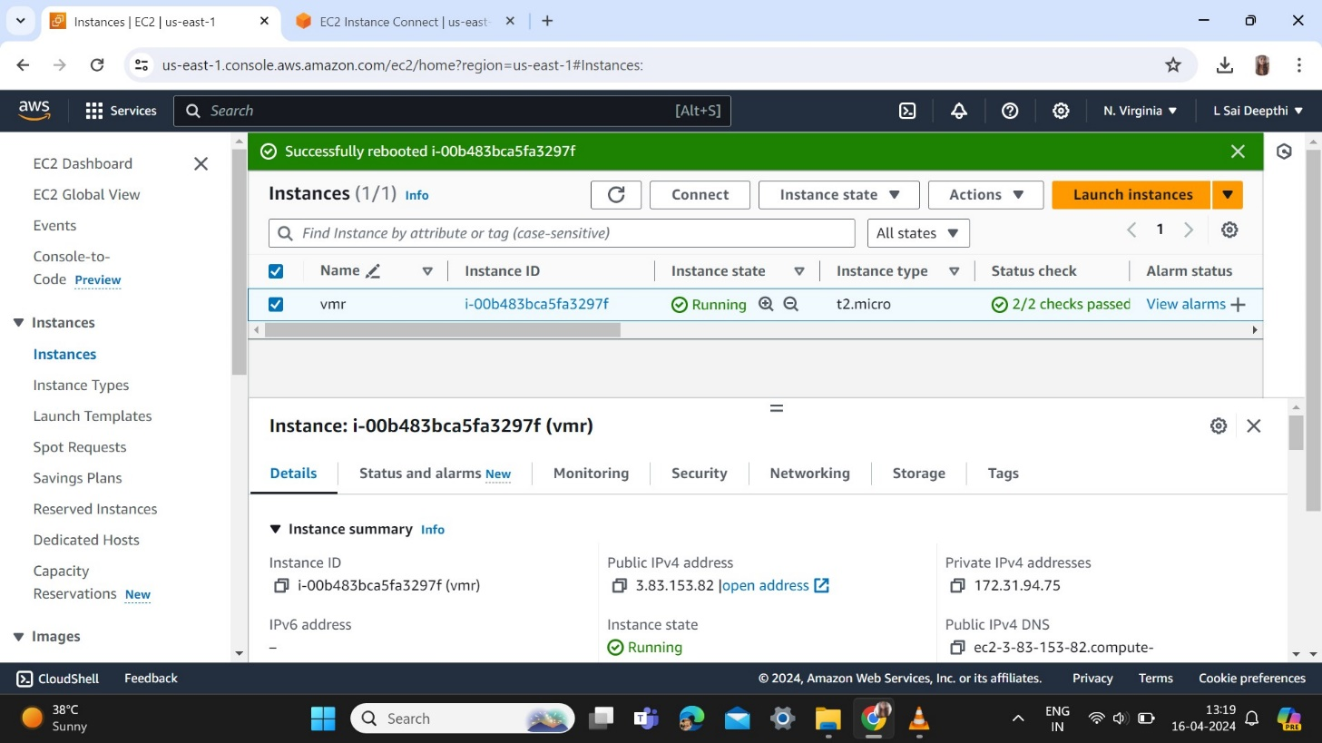

Step 5: Connect to the instance once again after rebooting and enter df -h then you will get 16G.

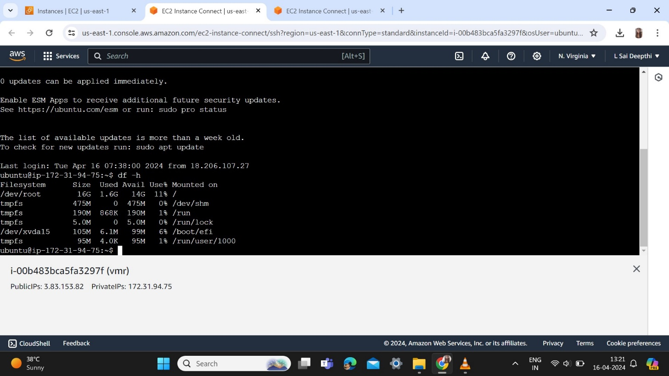

EBS

Step 6: Create a EBS volume where the availability zone is present.

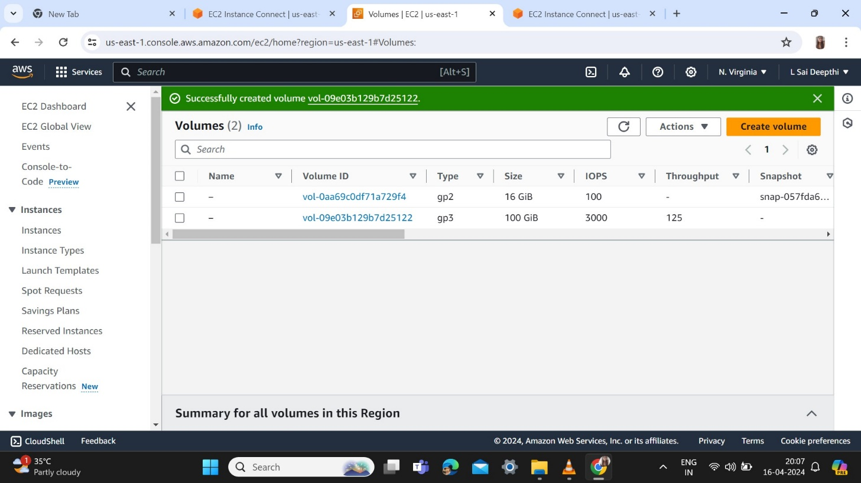

Step 7: Attach to the availability zone d and device name /dev/sdf then attach volume.

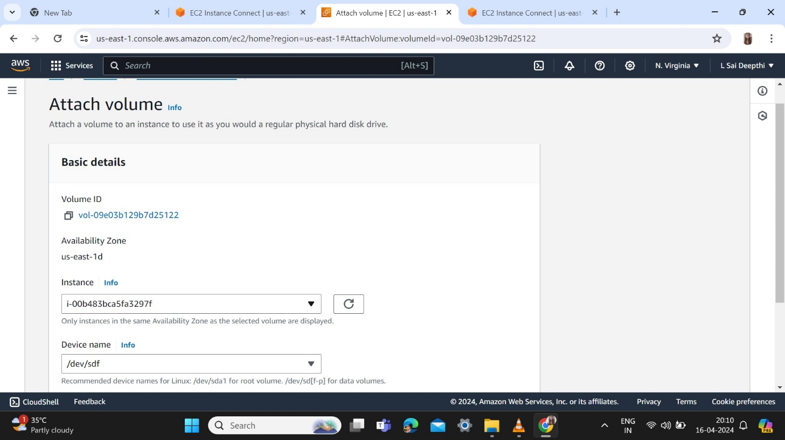

Step 8: We get 100G using lsblk command.

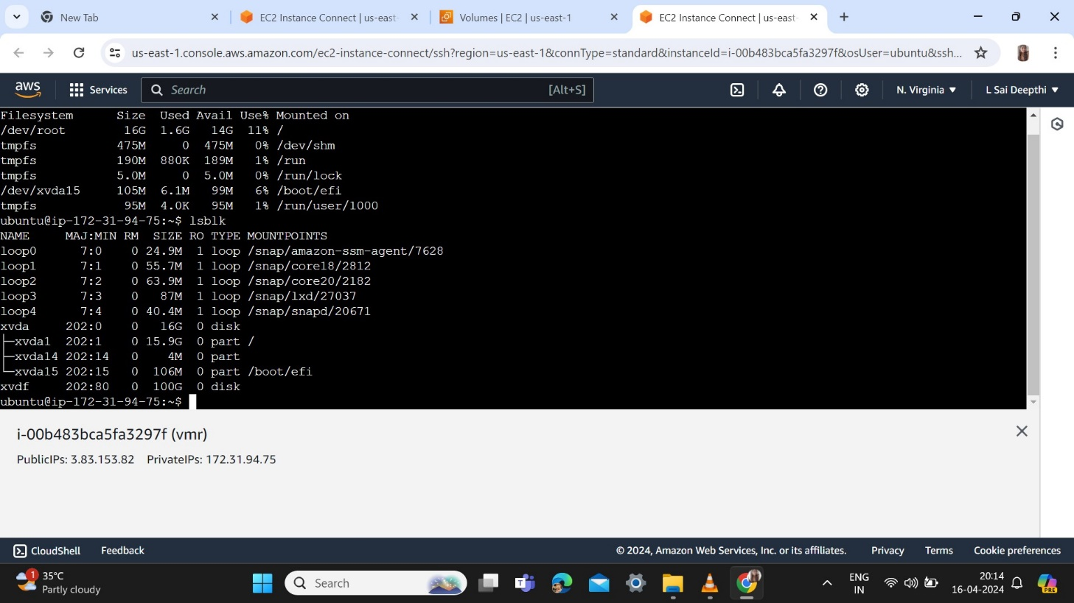

Step 9: To check if any file system file -s /dev/xvdf and a create a folder.

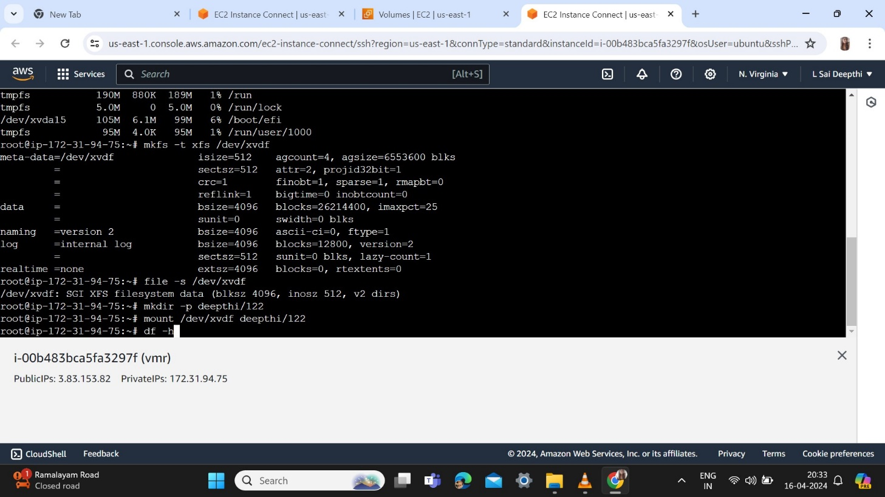

Step 10: Inserting data in file.

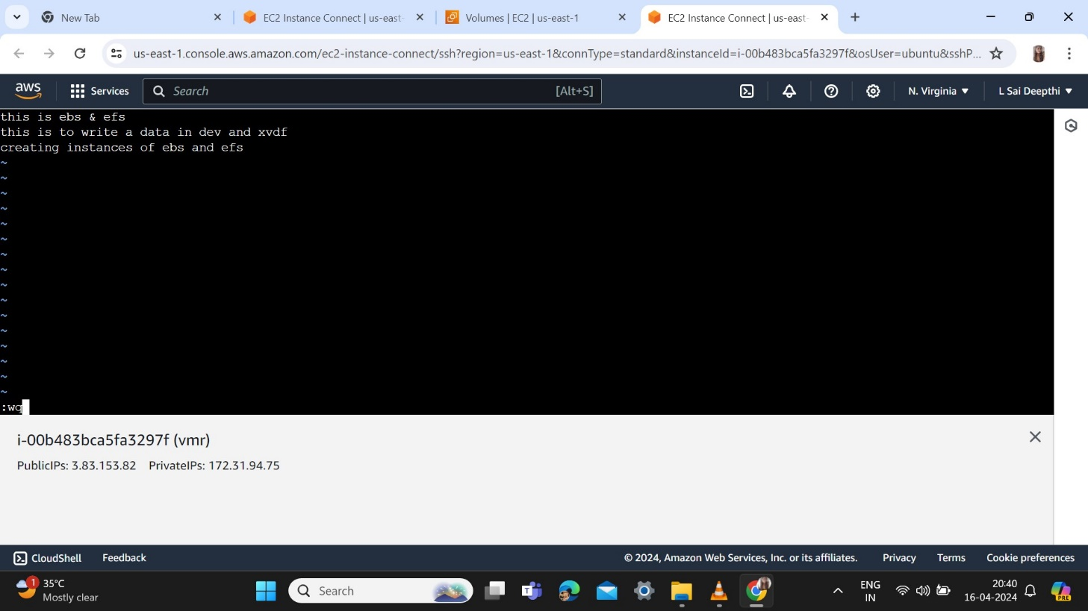

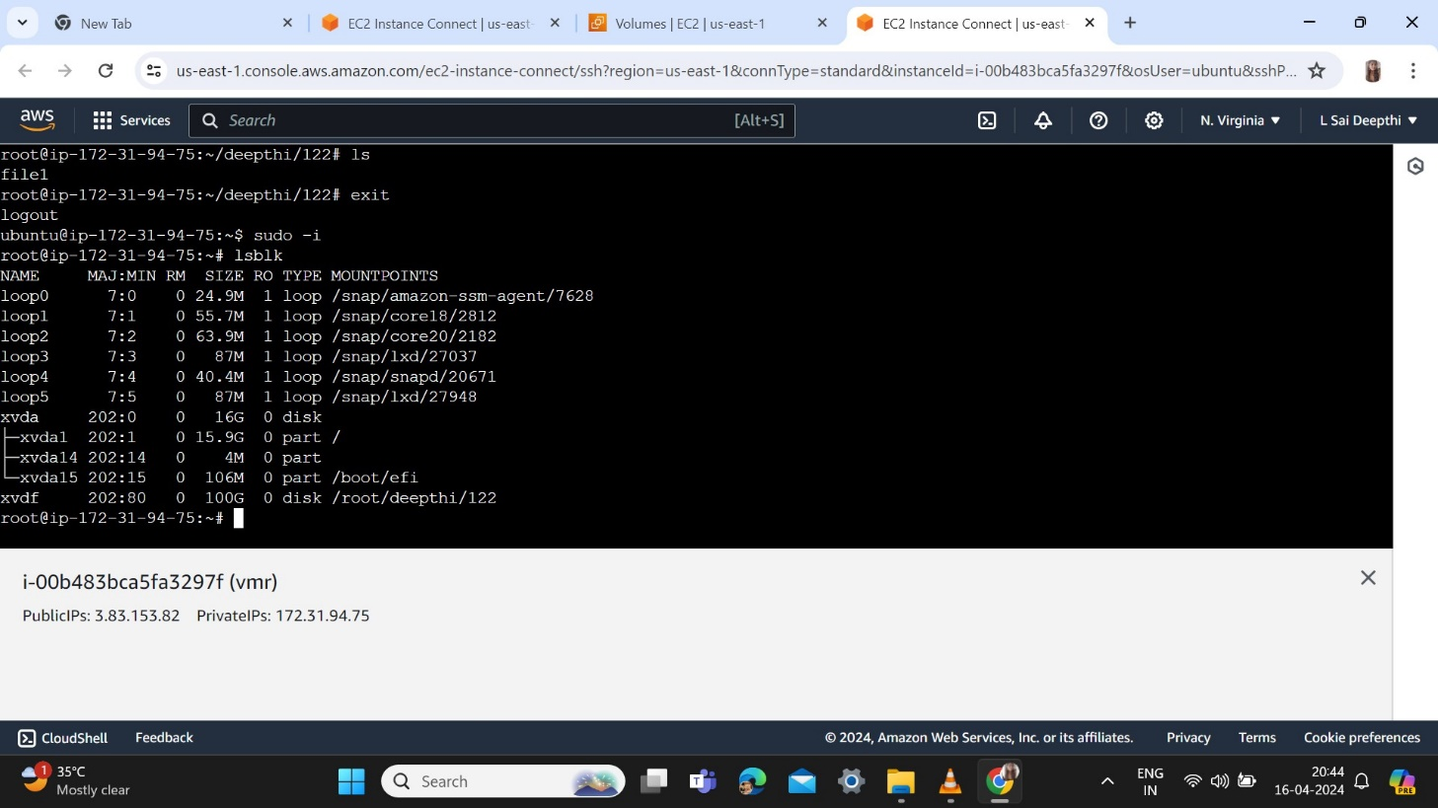

EFS

Step 11: Create a security group for EFS.

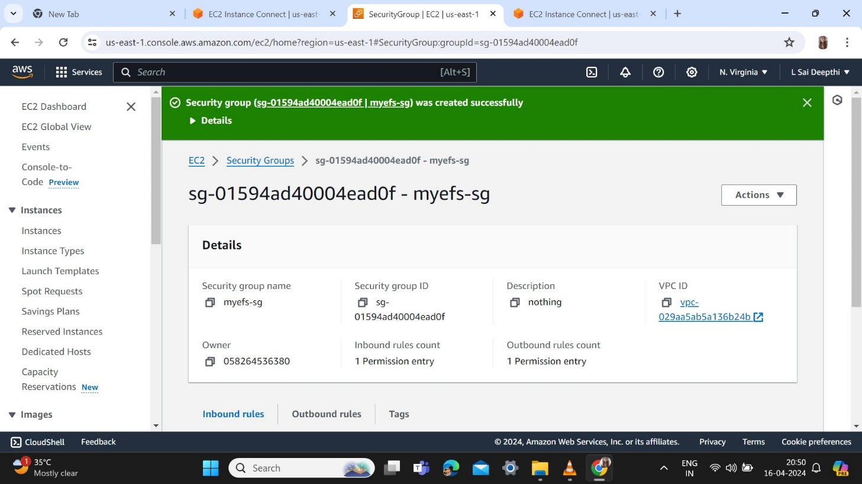

Step 12: Go to EFS and create a file system deepthi-efs.

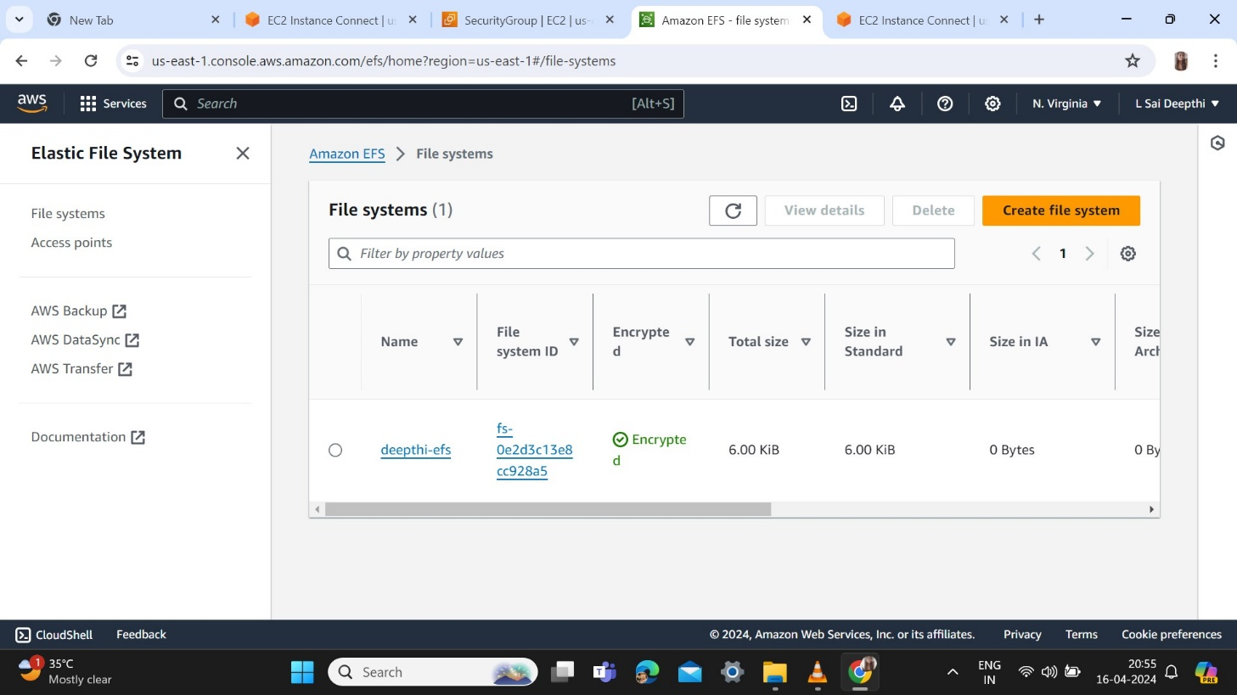

Step 13: Create EC2 instance with ec1 name and connect .

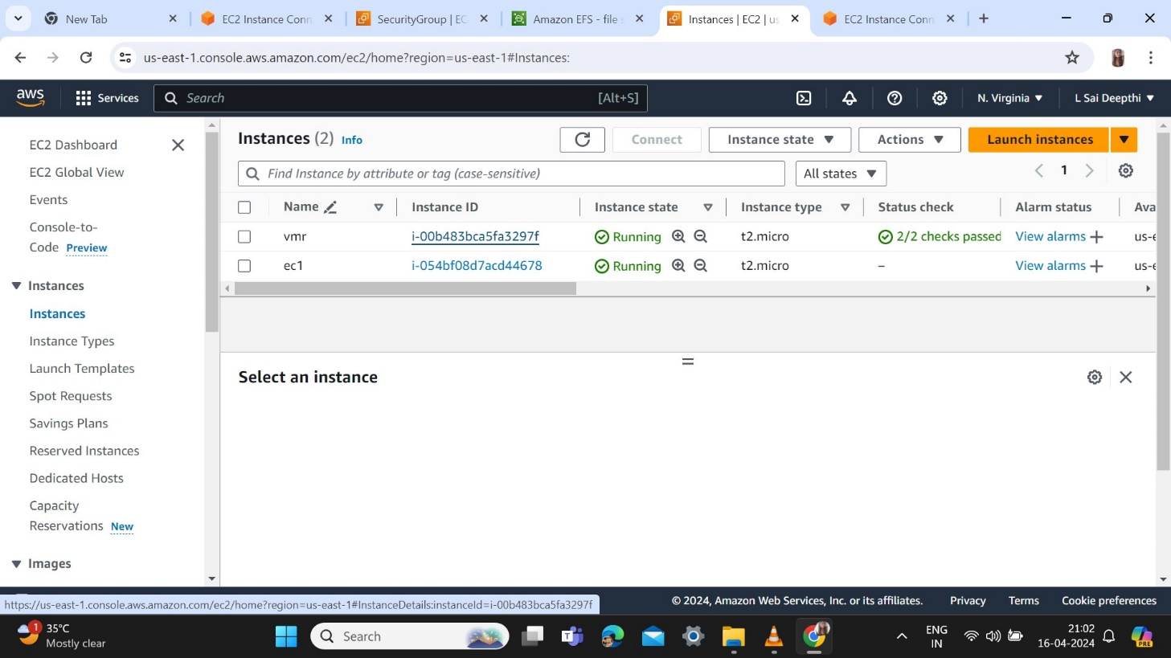

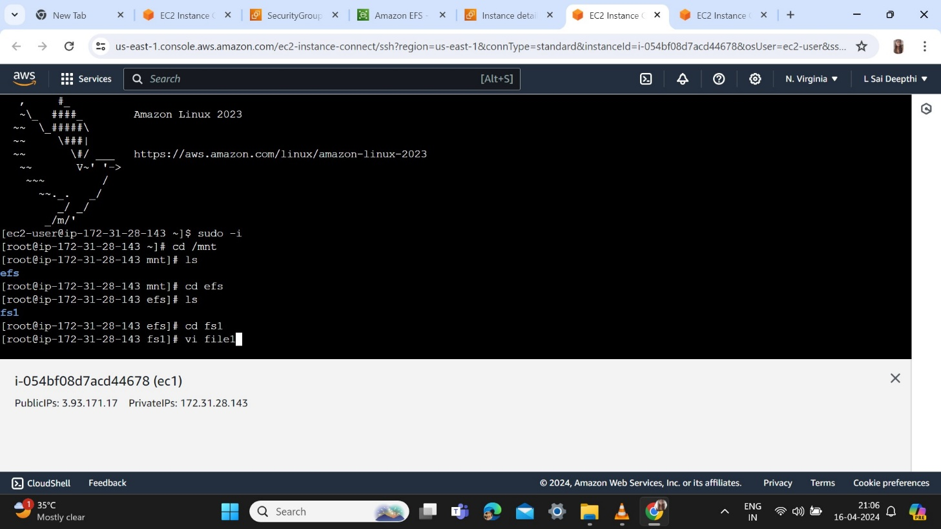

Step 14: Create a EC2 instance of name ec2 and connect.

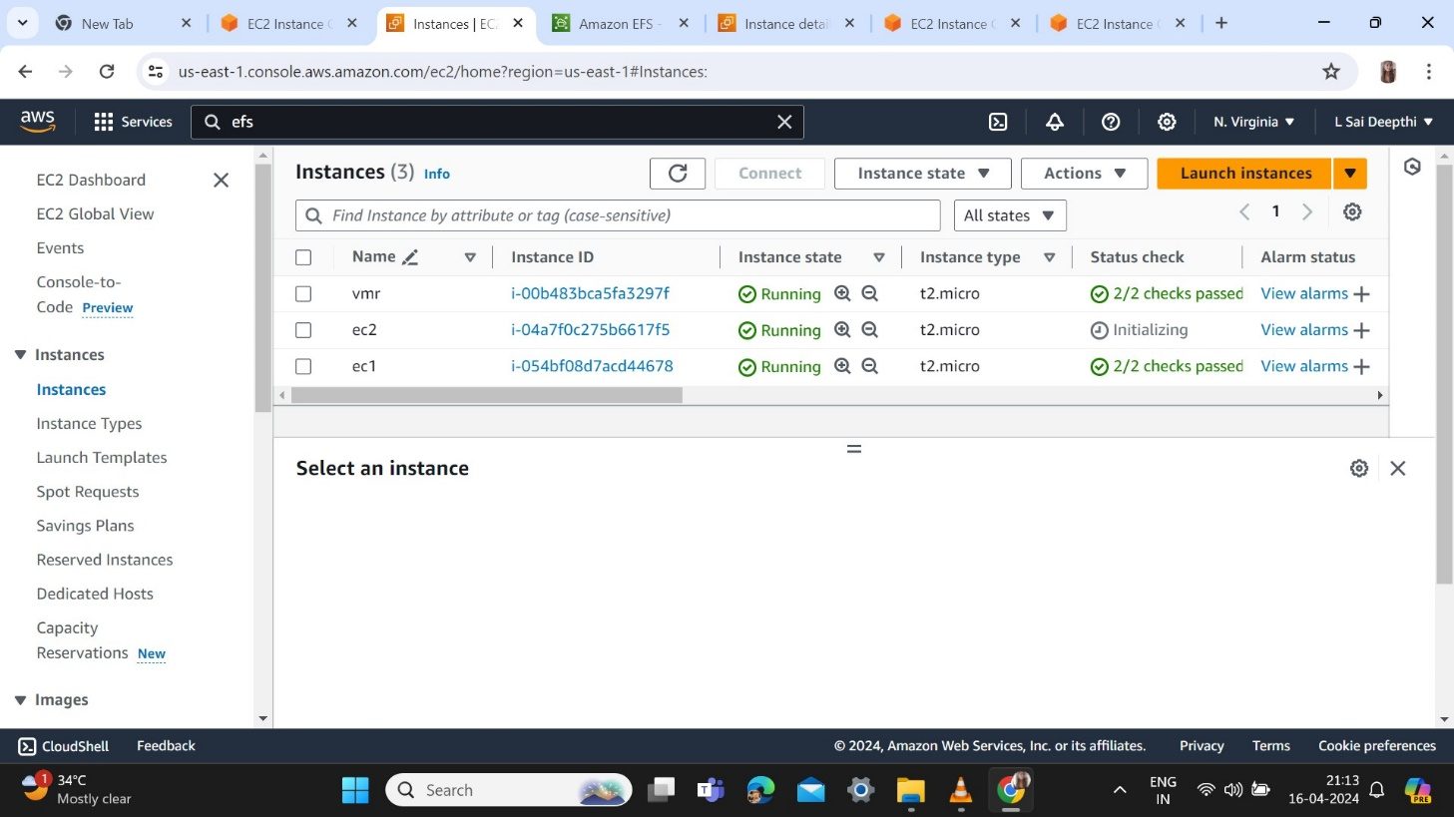

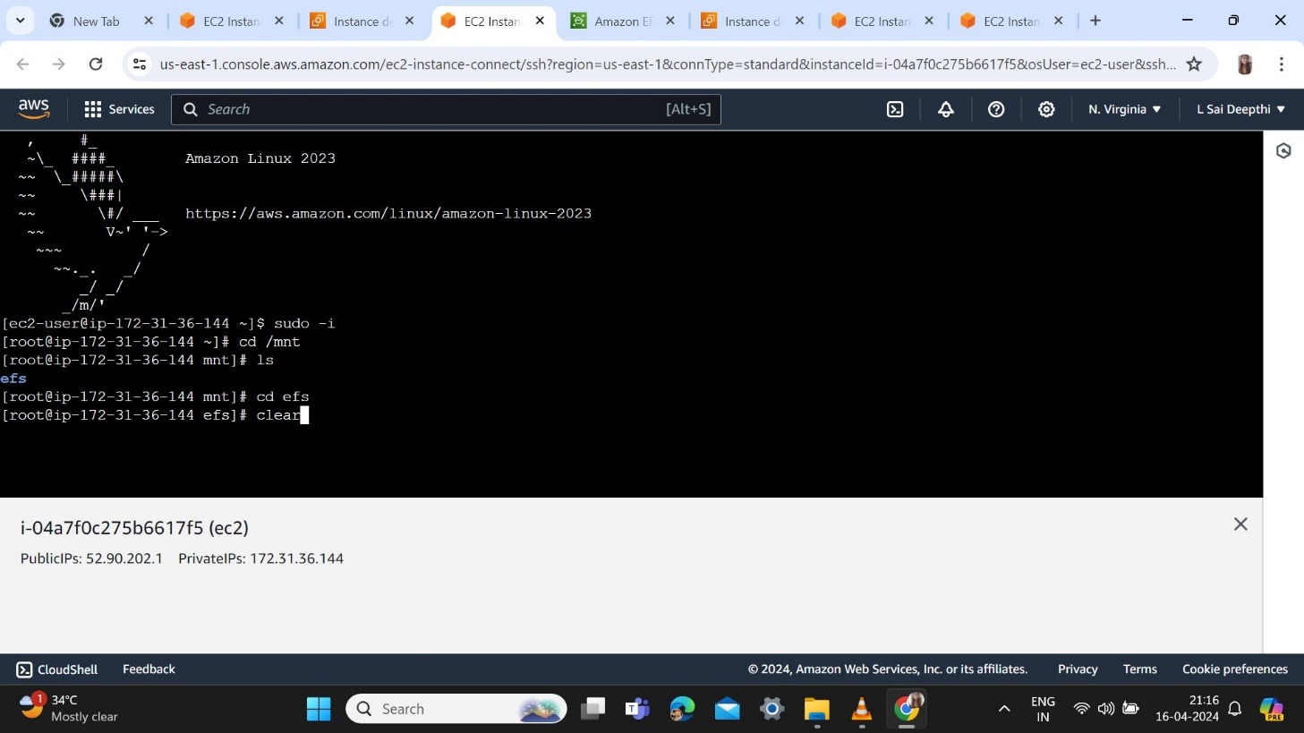

Step 15: Creating files and directories in both ec1 and ec2 instances .The created files in ec1 reflected in ec2.

